

MEKELLE UNIVERSITY

MEKELLE INSTITUTE OF TECHNOLOGY

DEPARTMENT OF INFORMATION TECHNOLOGY

Advanced Database Systems
Module

All Chapters in One
Compiled Module

Compiled By: Mezgebe Mehari | To: 2nd & 3rd Year IT Students

MU-MIT, Ethiopia
Semester-II, 2011 E.C

Table of Contents
CHAPTER - ONE: QUERY PROCESSING AND OPTIMIZATION 3
1.1 Overview of Query Optimization 3
1.2 Translating SQL Queries into Relational Algebra 4
1.3 Basic Algorithms for Executing Query Operations 6
1.3.1 External Sorting 6
1.3.2 Implementing the SELECT Operation 7
1.3.3 Implementing the JOIN Operation 9
1.4 Using Heuristics in Query Optimization 11
1.4.1 Notation for Query Trees and Query Graphs 11
1.5 Using Selectivity and Cost Estimates in Query Optimization 12
1.5.1 Catalog Information Used in Cost Functions 13
1.6 Overview of Query Optimization in ORACLE 14
1.7 Semantic Query Optimization 16
CHAPTER – TWO: TRANSACTION PROCESSING 17
2.1 Introduction to Transaction Processing 17
2.1.1 Single-User versus Multiuser Systems 17
2.1.2 Transactions, Read and Write Operations, and DBMS Buffers 18
2.2 Transaction Processing and System Concepts 20
2.2.1 Transaction States and Additional Operations 20
2.2.2 The System Log 21
2.3 Desirable Properties of Transactions 21
2.4 Schedules Based on Recoverability and Serializability 25
2.5 Transaction Support in SQL 30
CHAPTER – THREE: CONCURRENCY CONTROL TECHNIQUES 33
3.1 Introduction, Transaction Processing and System Concepts 33
3.2 Desirable Properties of Transactions 34
3.3 Schedules Based on Recoverability and Serializability 35
3.4 Transaction Support in SQL 35
CHAPTER – FOUR: TRANSACTION PROCESSING 35
4.1 Locking Techniques for Concurrency Control 35
4.2 Concurrency Control Based on Timestamp Ordering 35
4.3 Multiversion Concurrency Control Techniques 35
4.4 Validation (Optimistic) Concurrency Control Techniques 35
4.5 Granularity of Data Items and Multiple Granularity Locking 35
4.6 Using Locks for Concurrency Control in Indexes 35
CHAPTER – FIVE: DISTRIBUTED DATABASE SYSTEM 36
5.1 Distributed Database Concepts, Data Fragmentation, Replication 36
5.2 Allocation Techniques for Distributed Database Design 36
5.3 Concurrency Control and Recovery in Distributed Databases 36
5.4 Transaction Management in Distributed Databases 36
5.5 Types of Distributed Databases and Distributed DB in Oracle 36

CHAPTER - ONE: QUERY PROCESSING AND OPTIMIZATION
Query Processing and Optimization

Overview of Query Optimization
- In this chapter we will discuss the techniques used by a DBMS to process, optimize, and execute high-level queries.
- A query expressed in a high-level query language such as SQL must first be scanned, parsed, and validated. The scanner identifies the language tokens—such as SQL keywords, attribute names, and relation names—in the text of the query, whereas the parser checks the query syntax to determine whether it is formulated according to the syntax rules (rules of grammar) of the query language.
- The query must also be validated, by checking that all attribute and relation names are valid and semantically meaningful names in the schema of the particular database being queried.
- An internal representation of the query is then created, usually as a tree data structure called a query tree. It is also possible to represent the query using a graph data structure called a query graph.
- The DBMS must then devise an execution strategy for retrieving the result of the query from the database files. A query typically has many possible execution strategies, and the process of choosing a suitable one for processing a query is known as query optimization.
- From fundamentals of database course of chapter 2.5, the runtime database processor has the task of running the query code, whether in compiled or interpreted mode, to produce the query result. If a runtime error results, an error message is generated by the runtime database processor.
- The term optimization is actually a misnomer because in some cases the chosen execution plan is not the optimal (best) strategy—it is just a reasonably efficient strategy for executing the query. Finding the optimal strategy is usually too time-consuming except for the simplest of queries and may require information on how the files are implemented and even on the contents of the files—information that may not be fully available in the DBMS catalog.
- Hence, planning of an execution strategy may be a more accurate description than query optimization.
- If a DBMS provides only a navigational language, there is limited need or opportunity for extensive query optimization by the DBMS; instead, the programmer is given the capability to choose the "optimal" execution strategy. On the other hand, a high-level query language—such as SQL for relational DBMSs (RDBMSs) or OQL for object DBMSs (ODBMSs)—is more declarative in nature because it specifies what the intended results of the query are, rather than identifying the details of how the result should be obtained. Query optimization is thus necessary for queries that are specified in a high-level query language.
- A relational DBMS must systematically evaluate alternative query execution strategies and choose a reasonably efficient or optimal strategy. Each DBMS typically has a number of general database access algorithms that implement relational operations such as SELECT or JOIN or combinations of these operations. Only execution strategies that can be implemented by the DBMS access algorithms and that apply to the particular query and particular physical database design can be considered by the query optimization module.
- We will start in Section 1.2 with a general discussion of how SQL queries are typically translated into relational algebra queries and then optimized. We will then discuss algorithms for implementing relational operations in Section 1.3. Following this, we give an overview of query optimization strategies. There are two main techniques for implementing query optimization.
  - The first technique is based on heuristic rules for ordering the operations in a query execution strategy. A heuristic is a rule that works well in most cases but is not guaranteed to work well in every possible case. The rules typically reorder the operations in a query tree.
  - The second technique involves systematically estimating the cost of different execution strategies and choosing the execution plan with the lowest cost estimate.
- The two techniques are usually combined in a query optimizer. We will discuss heuristic optimization in Section 1.2 in detail. We then provide a brief overview of the factors considered during query optimization in the ORACLE commercial RDBMS in Section 1.6. Section 1.7 introduces the topic of semantic query optimization, in which known constraints are used to devise efficient query execution strategies.

Translating SQL Queries into Relational Algebra

- In practice, SQL is the query language that is used in most commercial RDBMSs. An SQL query is first translated into an equivalent extended relational algebra expression—represented as a query tree data structure—that is then optimized.
- Typically, SQL queries are decomposed into query blocks, which form the basic units that can be translated into the algebraic operators and optimized. A query block contains a single SELECT-FROM-WHERE expression, as well as GROUP BY and HAVING clauses if these are part of the block.
  - Hence, nested queries within a query are identified as separate query blocks. Because SQL includes aggregate operators—such as MAX, MIN, SUM, AND COUNT—these operators must also be included in the extended algebra, as we discussed in Fundamentals of Database Systems.
- Consider the following SQL query on the EMPLOYEE relation:

SELECT LNAME, FNAME
FROM EMPLOYEE
WHERE SALARY > (SELECT MAX (SALARY) FROM EMPLOYEE WHERE DNO=5);
- This query includes a nested subquery and hence would be decomposed into two blocks.
(SELECT MAX (SALARY)
FROM EMPLOYEE
WHERE DNO=5)
  - The inner block is:

  - And the outer block is:
SELECT LNAME, FNAME FROM EMPLOYEE WHERE SALARY > C

  - Where c represents the result returned from the inner block.
  - The inner block could be translated into the extended relational algebra expression:
MAX SALARY(sDNO=5(EMPLOYEE))

  - And the outer block into the expression:
pLNAME, FNAME(sSALARY>C(EMPLOYEE))

- The query optimizer would then choose an execution plan for each block. We should note that in the above example, the inner block needs to be evaluated only once to produce the maximum salary, which is then used—as the constant c—by the outer block.
  - We normally call such kind of nested query as an uncorrelated nested query.
  - It is much harder to optimize the more complex correlated nested queries, where a tuple variable from the outer block appears in the WHERE-clause of the inner block.

Basic Algorithms for Executing Query Operations

- An RDBMS must include algorithms for implementing the different types of relational operations (as well as other types of operations) that can appear in a query execution strategy.
  - These operations include the basic and extended relational algebra operations discussed in FDBS and, in many cases, combinations of these operations. For each such operation or combination of operations, one or more algorithms would typically be available to execute the operation(s).
- An algorithm may apply only to particular storage structures and access paths; if so, it can only be used if the files involved in the operation include these access paths.
  - In this section we discuss typical algorithms used to implement SELECT, JOIN, and other relational operations. We begin by discussing external sorting, which is at the heart of many relational operations that utilize sort- merge strategies. Then we discuss algorithms for implementing the SELECT and JOIN operation.

1.3.1 External Sorting

- Sorting is one of the primary algorithms used in query processing.
  - For example, whenever an SQL query specifies an ORDER BY-clause, the query result must be sorted.
- Sorting is also a key component in sort-merge algorithms used for JOIN and other operations (such as UNION and INTERSECTION), and in duplicate elimination algorithms for the PROJECT operation (when an SQL query specifies the DISTINCT option in the SELECT clause).
- External sorting refers to sorting algorithms that are suitable for large files of records stored on disk that do not fit entirely in main memory, such as most database files.
  - The typical external sorting algorithm uses a sort-merge strategy, which starts by sorting small sub-files—called runs—of the main file and then merges the sorted runs, creating larger sorted sub-files that are merged in turn.
- The sort-merge algorithm, like other database algorithms, requires buffer space in main memory, where the actual sorting and merging of the runs is performed.
  - It consists of two phases:
    - The sorting phase and
    - The merging phase
- In the sorting phase, runs (portions or pieces) of the file that can fit in the available buffer space are read into main memory, sorted using an internal sorting algorithm, and written back to disk as temporary sorted subfiles (or runs). The size of a run and number of initial runs is dictated by the number of file blocks (b) and the available buffer space.

  - For example, if = 5 blocks and the size of the file b = 1024 blocks, then =, or 205 initial runs each of size 5 blocks (except the last run which will have 4 blocks). Hence, after the sort phase, 205 sorted runs are stored as temporary sub-files on disk.
- In the merging phase, the sorted runs are merged during one or more passes. The degree of merging is the number of runs that can be merged together in each pass. In each pass, one buffer block is needed to hold one block from each of the runs being merged, and one block is needed for containing one block of the merge result.
  - In our example, = 4 (four-way merging), so the 205 initial sorted runs would be merged into 52 at the end of the first pass, which are then merged into 13, then 4, then 1 run, which means that four passes are needed. The minimum of 2 gives the worst-case performance of the algorithm, which is:
    - (2 * b) + (2 * (b * (log2 b)))

- The first term represents the number of block accesses for the sort phase, since each file block is accessed twice—once for reading into memory and once for writing the records back to disk after sorting.
- The second term represents the number of block accesses for the merge phase, assuming the worst-case of 2. In general, the log is taken to the base and the expression for number of block accesses becomes.

1.3.2 Implementing the SELECT Operation

- There are many options for executing a SELECT operation; some depend on the file having specific access paths and may apply only to certain types of selection conditions.
- We discuss some of the algorithms for implementing SELECT in this section. We will use the following operations, specified on the relational database, to illustrate our discussion:

(OP1): sSSN=’123456789’(EMPLOYEE) (OP2): sDNUMBER>5(DEPARTMENT) (OP3): sDNO=5(EMPLOYEE)
(OP4): sDNO=5 AND SALARY>30000 AND SEX=’F’(EMPLOYEE) (OP5): sESSN=’123456789’ AND PNO=10(WORKS_ON)

Search Methods for Simple Selection

- A number of search algorithms are possible for selecting records from a file. These are also known as file scans, because they scan the records of a file to search for and retrieve records that satisfy a selection condition. If the search algorithm involves the use of an index, the index search is called an index scan.
- The following search methods (S1 through S6) are examples of some of the search algorithms that can be used to implement a select operation:

S1. Linear search (brute force):
Retrieve every record in the file, and test whether its attribute values satisfy the selection condition.

S2. Binary search:
If the selection condition involves an equality comparison on a key attribute on which the file is ordered, binary search—which is more efficient than linear search—can be used. An example is OP1 if SSN is the ordering attribute for the EMPLOYEE file.

S3. Using a primary index (or hash key):
If the selection condition involves an equality comparison on a key attribute with a primary index (or hash key)—for example, SSN =‘123456789’ in OP1—use the primary index (or hash key) to retrieve the record. Note that this condition retrieves a single record (at most).

S4. Using a primary index to retrieve multiple records:
If the comparison condition is >, >=, <, or <= on a key field with a primary index—for example, DNUMBER > 5 in OP2—use the index to find the record satisfying the corresponding equality condition (DNUMBER = 5), then retrieve all subsequent records in the (ordered) file. For the condition DNUMBER < 5, retrieve all the preceding records.

S5. Using a clustering index to retrieve multiple records:
If the selection condition involves an equality comparison on a non-key attribute with a clustering index—for example, DNO = 5 in OP3—use the index to retrieve all the records satisfying the condition.

S6. Using a secondary (-tree) index on an equality comparison:
This search method can be used to retrieve a single record if the indexing field is a key (has unique values) or to retrieve multiple records if the indexing field is not a key. This can also be used for comparisons involving >, >=, <, or <=.

- Method S1 applies to any file, but all the other methods depend on having the appropriate access path on the attribute used in the selection condition. Methods S4 and S6 can be used to retrieve records in a certain range—for example, 30000<=SALARY<=35000. Queries involving such conditions are called range queries.

1.3.3 Implementing the JOIN Operation

- The JOIN operation is one of the most time-consuming operations in query processing. Many of the join operations encountered in queries are of the EQUIJOIN and NATURAL JOIN varieties, so we consider only these two here. For the remainder of this chapter, the term join refers to an EQUIJOIN (or NATURAL JOIN).
- There are many possible ways to implement a two-way join, which is a join on two files. Joins involving more than two files are called multiway joins. The number of possible ways to execute multiway joins grows very rapidly. In this section we discuss techniques for implementing only two-way joins.
- The algorithms we consider are for join operations of the form:
RA=B S
where A and B are domain-compatible attributes of R and S, respectively. The methods we discuss can be extended to more general forms of join.
- We illustrate four of the most common techniques for performing such a join, using the following example operations:
(OP6): EMPLOYEEDNO=DNUMBER DEPARTMENT

(OP7): DEPARTMENTMGRSSN=SSN EMPLOYEE

Methods for Implementing Joins
J1. Nested-loop join (brute force):
For each record t in R (outer loop), retrieve every record s from S (inner loop) and test whether the two records satisfy the join condition t[A] = s[B].

•J2. Single-loop join (using an access structure to retrieve the matching records):
If an index (or hash key) exists for one of the two join attributes—say, B of S—retrieve each record t in R, one at a time (single loop), and then use the access structure to retrieve directly all matching records s from S that satisfy s[B] = t[A].

J3. Sort–merge join:
  - If the records of R and S are physically sorted (ordered) by value of the join attributes A and B, respectively, we can implement the join in the most efficient way possible.
  - Both files are scanned concurrently in order of the join attributes, matching the records that have the same values for A and B. If the files are not sorted, they may be sorted first by using external sorting.
    - In this method, pairs of file blocks are copied into memory buffers in order and the records of each file are scanned only once each for matching with the other file—unless both A and B are non-key attributes, in which case the method needs to be modified slightly.
  - The indexes provide the ability to access (scan) the records in order of the join attributes, but the records themselves are physically scattered all over the file blocks, so this method may be quite inefficient, as every record access may involve accessing a different disk block.

J4. Hash-join:
- The records of files R and S are both hashed to the same hash file, using the same hashing function on the join attributes A of R and B of S as hash keys.
- First, a single pass through the file with fewer records (say, R) hashes its records to the hash file buckets;
  - This is called the partitioning phase, since the records of R are partitioned into the hash buckets.
- In the second phase, called the probing phase, a single pass through the other file (S) then hashes each of its records to probe the appropriate bucket, and that record is combined with all matching records from R in that bucket.
- This simplified description of hash-join assumes that the smaller of the two files fits entirely into memory buckets after the first phase. We will discuss variations of hash-join that do not require this assumption below.

Using Heuristics in Query Optimization

- In this section we will discuss optimization techniques that apply heuristic rules to modify the internal representation of a query—which is usually in the form of a query tree or a query graph data structure—to improve its expected performance.
- The parser of a high-level query first generates an initial internal representation, which is then optimized according to heuristic rules.
  - Following that, a query execution plan is generated to execute groups of operations based on the access paths available on the files involved in the query.
- One of the main heuristic rules is to apply SELECT and PROJECT operations before applying the JOIN or other binary operations.
  - This is because the size of the file resulting from a binary operation— such as JOIN—is usually a multiplicative function of the sizes of the input files.
  - The SELECT and PROJECT operations reduce the size of a file and hence should be applied before a join or other binary operation.
- Query tree and query graph notations can be used as the basis for the data structures that are used for internal representation of queries.
  - A query tree is used to represent a relational algebra or extended relational algebra expression, whereas a query graph is used to represent a relational calculus expression.

1.4.1 Notation for Query Trees and Query Graphs

- A query tree is a tree data structure that corresponds to a relational algebra expression. It represents the input relations of the query as leaf nodes of the tree, and represents the relational algebra operations as internal nodes.
- An execution of the query tree consists of executing an internal node operation whenever its operands are available and then replacing that internal node by the relation that results from executing the operation.
  - The execution terminates when the root node is executed and produces the result relation for the query.

Example:DNUM=DNUMBER(DEPARTMENT))MGRSSN=SSN(EMPLOYEE)) corresponds to this query:
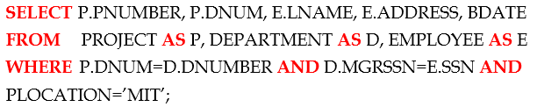
- The three relations PROJECT, DEPARTMENT, and EMPLOYEE are represented by leaf nodes P, D, and E, while the relational algebra operations of the expression are represented by internal tree nodes.
- As we can observe, the query tree represents a specific order of operations for executing a query. A more neutral representation of a query is the query graph notation.
  - Relations in the query are represented by relation nodes, which are displayed as single circles.
  - Constant values, typically from the query selection conditions, are represented by constant nodes, which are displayed as double circles.
  - Selection and join conditions are represented by the graph edges.
  - Finally, the attributes to be retrieved from each relation are displayed in square brackets above each relation.
- The query graph representation does not indicate an order on which operations to perform first. There is only a single graph corresponding to each query.
- Although some optimization techniques were based on query graphs, it is now generally accepted that query trees are preferable because, in practice, the query optimizer needs to show the order of operations for query execution, which is not possible in query graphs.

Using Selectivity and Cost Estimates in Query Optimization

- A query optimizer should not depend solely on heuristic rules; it should also estimate and compare the costs of executing a query using different execution strategies and should choose the strategy with the lowest cost estimate.
  - For this approach to work, accurate cost estimates are required so that different strategies are compared fairly and realistically.
- In addition, we must limit the number of execution strategies to be considered; otherwise, too much time will be spent making cost estimates for the many possible execution strategies.
- Hence, this approach is more suitable for compiled queries where the optimization is done at compile time and the resulting execution strategy code is stored and executed directly at runtime.
- For interpreted queries, where the entire process occurs at runtime, a full-scale optimization may slow down the response time.
  - A more elaborate optimization is indicated for compiled queries, whereas a partial, less time-consuming optimization works best for interpreted queries.
  - We call this approach cost-based query optimization, and it uses traditional optimization techniques that search the solution space to a problem for a solution that minimizes an objective (cost) function.
  - The cost functions used in query optimization are estimates and not exact cost functions, so the optimization may select a query execution strategy that is not the optimal one.
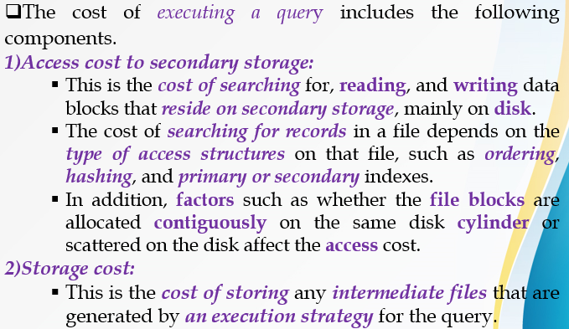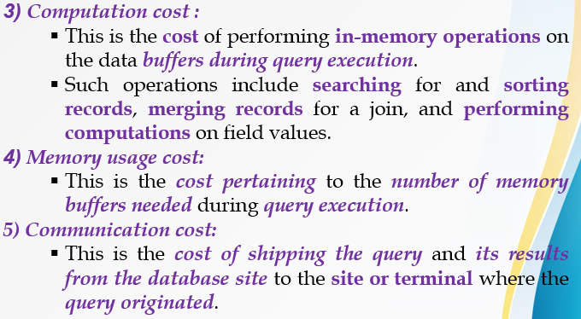

1.5.1 Catalog Information Used in Cost Functions
- To estimate the costs of various execution strategies, we must keep track of any information that is needed for the cost functions.
- This information may be stored in the DBMS catalog, where it is accessed by the query optimizer.
- First, we must know the size of each file.
  - For a file whose records are all of the same type, the number of records (tuples) (r), the (average) record size (R), and the number of blocks (b) (or close estimates of them) are needed.
  - The blocking factor (bfr) for the file may also be needed.
- We must also keep track of the primary access method and the primary access attributes for each file.
  - The file records may be unordered, ordered by an attribute with or without a primary or clustering index, or hashed on a key attribute.
  - Information is kept on all secondary indexes and indexing attributes.
  - The number of levels (x) of each multilevel index (primary, secondary, or clustering) is needed for cost functions that estimate the number of block accesses that occur during query execution.
  - In some cost functions the number of first-level index blocks is needed.
- Another important parameter is the number of distinct values (d) of an attribute and its selectivity (sl), which is the fraction of records satisfying an equality condition on the attribute.
  - This allows estimation of the selection cardinality (s = sl * r) of an attribute, which is the average number of records that will satisfy an equality selection condition on that attribute.
    - For a key attribute, d = r, sl =1/r and hence s = sl * r, since sl =1/r then s = 1/r * r = 1.
    - For a non-key attribute, by making an assumption that the d distinct values are uniformly distributed among the records, we estimate sl = (1/d) and hence s = sl * r, since sl =1/d then s = 1/d * r = (r/d).
- Information such as the number of index levels is easy to maintain because it does not change very often. However, other information may change frequently;
  - For example, the number of records r in a file changes every time a record is inserted or deleted.
- The query optimizer will need reasonably close but not necessarily completely up-to-the-minute values of these parameters for use in estimating the cost of various execution strategies.

Overview of Query Optimization in ORACLE
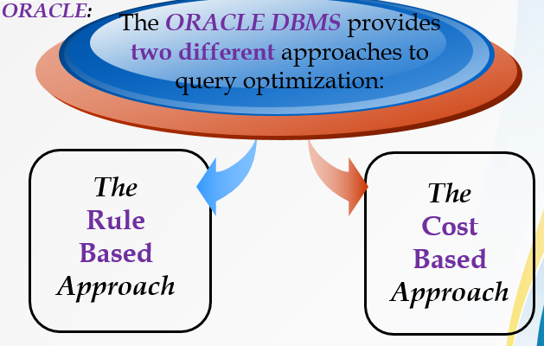
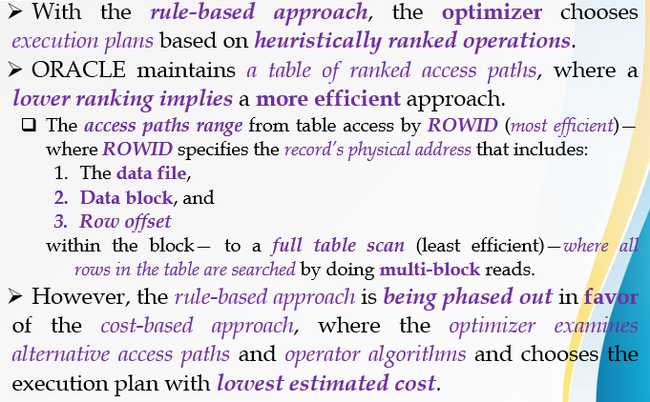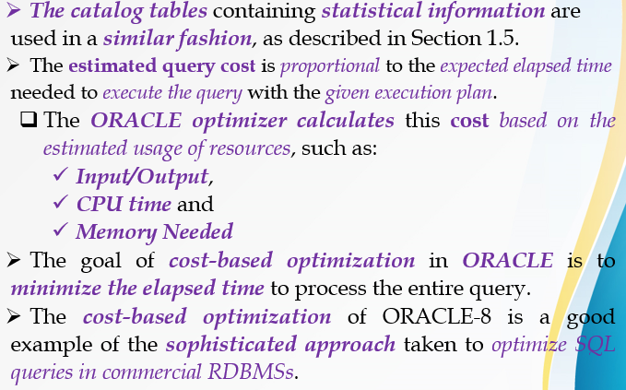

Semantic Query Optimization
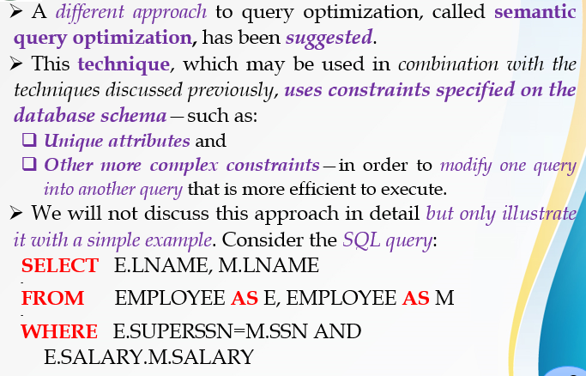
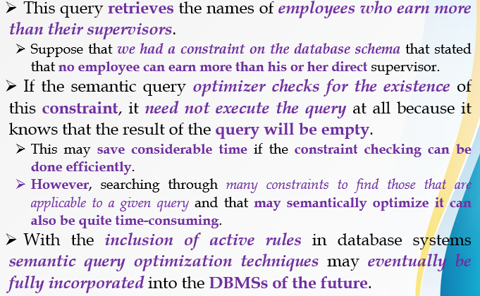

CHAPTER – TWO: TRANSACTION PROCESSING
Transaction Processing

2.1 Introduction to Transaction Processing

- The concept of transaction provides a mechanism for describing logical units of database processing.
- Transaction processing systems are systems with large databases and hundreds of concurrent users that are executing database transactions.
  - Examples of such systems include systems for reservations, banking, credit card processing, stock markets, supermarket checkout, and other similar systems.
- They require high availability and fast response time for hundreds of concurrent users.
  - In this chapter we present the concepts that are needed in transaction processing systems. We define the concept of a transaction, which is used to represent a logical unit of database processing that must be completed in its entirety to ensure correctness. We discuss the concurrency control problem, which occurs when multiple transactions submitted by various users interfere with one another in a way that produces incorrect results. We also discuss recovery from transaction failures.

2.1.1 Single-User versus Multiuser Systems
- One criterion for classifying a database system is according to the number of users who can use the system concurrently—that is, at the same time.
- A DBMS is single-user if at most one user at a time can use the system, and it is multiuser if many users can use the system—and hence access the database—concurrently.
- Single-user DBMSs are mostly restricted to some microcomputer systems; most other DBMSs are multiuser.
  - For example, an airline reservations system is used by hundreds of travel agents and reservation clerks concurrently. Systems in banks, insurance agencies, stock exchanges, supermarkets, and the like are also operated on by many users who submit transactions concurrently to the system.
- Multiple users can access databases—and use computer systems—simultaneously because of the concept of multiprogramming, which allows the computer to execute multiple programs—or processes—at the same time.
- If only a single central processing unit (CPU) exists, it can actually execute at most one process at a time.
- However, multiprogramming operating systems execute some commands from one process, then suspend that process and execute some commands from the next process, and so on.
  - A process is resumed at the point where it was suspended whenever it gets its turn to use the CPU again.
- Hence, concurrent execution of processes is actually interleaved, in two processes A and B executing concurrently in an interleaved fashion.
  - Interleaving keeps the CPU busy when a process requires an input or output (I/O) operation, such as reading a block from disk.
  - The CPU is switched to execute another process rather than remaining idle during I/O time. Interleaving also prevents a long process from delaying other processes.
- If the computer system has multiple hardware processors (CPUs), parallel processing of multiple processes is possible.
  - Most of the theory concerning concurrency control in databases is developed in terms of interleaved concurrency, so for the remainder of this chapter we assume this model.
  - In a multiuser DBMS, the stored data items are the primary resources that may be accessed concurrently by interactive users or application programs, which are constantly retrieving information from and modifying the database.

2.1.2 Transactions, Read and Write Operations, and DBMS Buffers

- A transaction is a logical unit of database processing that includes one or more database access operations—these can include insertion, deletion, modification, or retrieval operations.
- The database operations that form a transaction can either be embedded within an application program or they can be specified interactively via a high-level query language such as SQL.
- One way of specifying the transaction boundaries is by specifying explicit begin transaction and end transaction statements in an application program; in this case, all database access operations between the two are considered as forming one transaction.
- A single application program may contain more than one transaction if it contains several transaction boundaries.
  - If the database operations in a transaction do not update the database but only retrieve data, the transaction is called a read-only transaction.
- The model of a database that is used to explain transaction processing concepts is much simplified.
- A database is basically represented as a collection of named data items. The size of a data item is called its granularity, and it can be a field of some record in the database, or it may be a larger unit such as a record or even a whole disk block, but the concepts we discuss are independent of the data item granularity.

- Using this simplified database model, the basic database access operations that a transaction can include are as follows:

    - read_item(X): Reads a database item named X into a program variable. To simplify our notation, we assume that the program variable is also named X.
    - write_item(X): Writes the value of program variable X into the database item named X.
- It is obvious that the basic unit of data transfer from disk to main memory is one block. Executing a read_item(X) command includes the following steps:

- Find the address of the disk block that contains item X.
- Copy that disk block into a buffer in main memory (if that disk block is not already in some main memory buffer).
- Copy item X from the buffer to the program variable named X.

- Executing a write_item(X) command includes the following steps:

- Find the address of the disk block that contains item X.
- Copy that disk block into a buffer in main memory (if that disk block is not already in some main memory buffer).
- Copy item X from the program variable named X into its correct location in the buffer.
- Store the updated block from the buffer back to disk (either immediately or at some later point in time).

- Step 4 is the one that actually updates the database on disk. In some cases the buffer is not immediately stored to disk, in case additional changes are to be made to the buffer. Usually, the decision about when to store back a modified disk block that is in a main memory buffer is handled by the recovery manager of the DBMS in cooperation with the underlying operating system.
- The DBMS will generally maintain a number of buffers in main memory that hold database disk blocks containing the database items being processed.
- When these buffers are all occupied, and additional database blocks must be copied into memory, some buffer replacement policy is used to choose which of the current buffers is to be replaced.
- If the chosen buffer has been modified, it must be written back to disk before it is reused.
  - A transaction includes read_item and write_item operations to access and update the database. The read-set of a transaction is the set of all items that the transaction reads, and the write-set is the set of all items that the transaction writes.

Transaction Processing and System Concepts

2.2.1 Transaction States and Additional Operations
- A transaction is an atomic unit of work that is either completed in its entirety or not done at all.
- For recovery purposes, the system needs to keep track of when the transaction starts, terminates, and commits or aborts (see below).
- Hence, the recovery manager keeps track of the following operations:
- BEGIN_TRANSACTION: This marks the beginning of transaction execution.
- READ or WRITE: These specify read or write operations on the database items that are executed as part of a transaction.
- END_TRANSACTION: This specifies that READ and WRITE transaction operations have ended and marks the end of transaction execution.
  - However, at this point it may be necessary to check whether the changes introduced by the transaction can be permanently applied to the database (committed) or whether the transaction has to be aborted because it violates serializability or for some other reason.
- COMMIT_TRANSACTION: This signals a successful end of the transaction so that any changes (updates) executed by the transaction can be safely committed to the database and will not be undone.
- ROLLBACK (or ABORT): This signals that the transaction has ended unsuccessfully, so that any changes or effects that the transaction may have applied to the database must be undone.
- A transaction goes into an active state immediately after it starts execution, where it can issue READ and WRITE operations. When the transaction ends, it moves to the partially committed state.
  - At this point, some recovery protocols need to ensure that a system failure will not result in an inability to record the changes of the transaction permanently (usually by recording changes in the system log, discussed in the next sub-section).
    - Once this check is successful, the transaction is said to have reached its commit point and enters the committed state.
    - Once a transaction is committed, it has concluded its execution successfully and all its changes must be recorded permanently in the database.
- However, a transaction can go to the failed state if one of the checks fails or if the transaction is aborted during its active state.
  - The transaction may then have to be rolled back to undo the effect of its WRITE operations on the database.
  - The terminated state corresponds to the transaction leaving the system.
  - The transaction information that is maintained in system tables while the transaction has been running is removed when the transaction terminates.
- Failed or aborted transactions may be restarted later—either automatically or after being resubmitted by the user—as brand new transactions.

2.2.2 The System Log
- To be able to recover from failures that affect transactions, the system maintains a log to keep track of all transaction operations that affect the values of database items.
  - This information may be needed to permit recovery from failures. The log is kept on disk, so it is not affected by any type of failure except for disk or catastrophic failure.
  - In addition, the log is periodically backed up to archival storage (tape) to guard against such catastrophic failures.
- We now list the types of entries—called log records—that are written to the log and the action each performs. In these entries, T refers to a unique transaction-id that is generated automatically by the system and is used to identify each transaction:
- [start_transaction, T]: Indicates that transaction T has started execution.
- [write_item, T,X,old_value,new_value]: Indicates that transaction T has changed the value of database item X from old_value to new_value.
- [read_item, T, X]: Indicates that transaction T has read the value of database item X.
- [commit,T]: Indicates that transaction T has completed successfully, and affirms that its effect can be committed (recorded permanently) to the database.
- [abort,T]: Indicates that transaction T has been aborted.
- Notice that we assume here that all permanent changes to the database occur within transactions, so the notion of recovery from a transaction failure amounts to either undoing or redoing transaction operations individually from the log.
- If the system crashes, we can recover to a consistent database state by examining the log.
  - Because the log contains a record of every WRITE operation that changes the value of some database item, it is possible to undo the effect of these WRITE operations of a transaction T by tracing backward through the log and resetting all items changed by a WRITE operation of T to their old_values.
- Redoing the operations of a transaction may also be needed if all its updates are recorded in the log but a failure occurs before we can be sure that all these new_values have been written permanently in the actual database on disk.
- Redoing the operations of transaction T is applied by tracing forward through the log and setting all items changed by a WRITE operation of T to their new_values.

Desirable Properties of Transactions

- Transactions should possess several properties. These are often called the ACID properties, and they should be enforced by the concurrency control and recovery methods of the DBMS. The following are the ACID properties:
1. Atomicity: A transaction is an atomic unit of processing; it is either performed in its entirety or not performed at all.
2. Consistency preservation: A transaction is consistency preserving if its complete execution take(s) the database from one consistent state to another.
3. Isolation: A transaction should appear as though it is being executed in isolation from other transactions. That is, the execution of a transaction should not be interfered with by any other transactions executing concurrently.
4. Durability or permanency: The changes applied to the database by a committed transaction must persist in the database. These changes must not be lost because of any failure.
- The atomicity property requires that we execute a transaction to completion.
  - It is the responsibility of the transaction recovery subsystem of a DBMS to ensure atomicity.
  - If a transaction fails to complete for some reason, such as a system crash in the midst of transaction execution, the recovery technique must undo any effects of the transaction on the database.
- The preservation of consistency is generally considered to be the responsibility of the programmers who write the database programs or of the DBMS module that enforces integrity constraints.
  - Recall that a database state is a collection of all the stored data items (values) in the database at a given point in time.
  - A consistent state of the database satisfies the constraints specified in the schema as well as any other constraints that should hold on the database.
  - A database program should be written in a way that guarantees that, if the database is in a consistent state before executing the transaction, it will be in a consistent state after the complete execution of the transaction, assuming that no interference with other transactions occurs.
- Isolation is enforced by the concurrency control subsystem of the DBMS.
  - If every transaction does not make its updates visible to other transactions until it is committed, one form of isolation is enforced that solves the temporary update problem and eliminates cascading rollbacks.
  - There have been attempts to define the level of isolation of a transaction.
    - A transaction is said to have level 0 (zero) isolation if it does not overwrite the dirty reads of higher-level transactions.
    - A level 1 (one)-isolation transaction has no lost updates; and
    - Level 2-isolation has no lost updates and no dirty reads.
    - Finally, level 3 isolation (also called true isolation) has, in addition to degree 2 properties, repeatable reads.
- Finally, the durability property is the responsibility of the recovery subsystem of the DBMS.

Details of ACID properties with Examples:
■ Transaction to transfer $50 from account A to account B:

1. read (A)

2. A := A – 50

3. write(A)

4. read(B)

5. B := B + 50

6. write(B)

■ Atomicity requirement

●If the transaction fails after step 3 and before step 6, money will be “lost” leading to an inconsistent database state

 Failure could be due to software or hardware

●The system should ensure that updates of a partially executed transaction are not reflected in the database
■ Durability requirement — once the user has been notified that the transaction has completed (i.e., the transfer of the $50 has taken place), the updates to the database by the transaction must persist even if there are software or hardware failures.

■ Transaction to transfer $50 from account A to account B:
1. read(A)
2. A := A – 50
3. write(A)
4. read(B)
5. B := B + 50
6. write(B)
■ Consistency requirement in above example:
● The sum of A and B is unchanged by the execution of the transaction
■ In general, consistency requirements include

- Explicitly specified integrity constraints such as primary keys and foreign keys
- Implicit integrity constraints
  - e.g. sum of balances of all accounts, minus sum of loan amounts must equal value of cash­in­hand
●A transaction must see a consistent database.
● During transaction execution the database may be temporarily inconsistent.
●When the transaction completes successfully the database must be consistent
- Erroneous transaction logic can lead to inconsistency

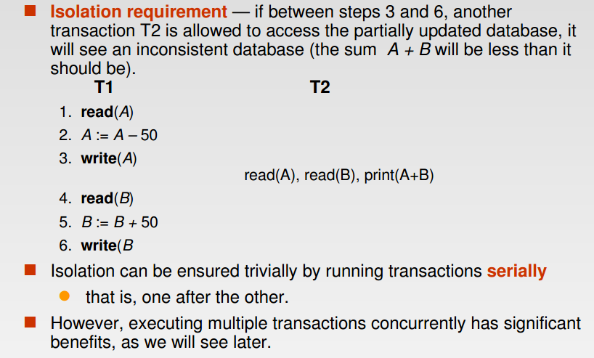
Implementation of Atomicity and Durability
■The recovery­management component of a database system implements the support for atomicity and durability.
E.g. The shadow­database scheme:

● All updates are made on a shadow copy of the database

●db_pointer is made to point to the updated shadow copy
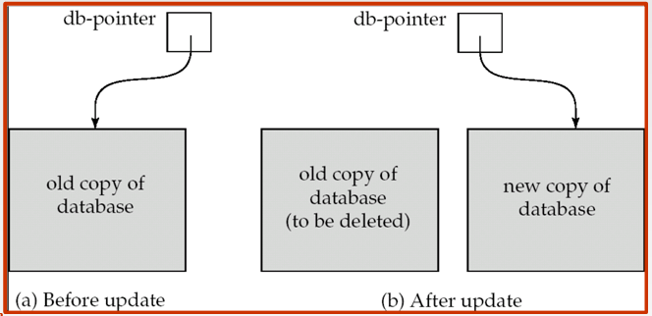

■ db_pointer always points to the current consistent copy of the database.

● In case transaction fails, old consistent copy pointed to by db_pointer can be used, and the shadow copy can be deleted.

■ The shadow­database scheme:

● Assumes that only one transaction is active at a time.

● Assumes disks do not fail

● Useful for text editors, but

■ extremely inefficient for large databases

– Variant called shadow paging reduces copying of data, but is still not practical for large databases

● Does not handle concurrent transactions

Schedules Based on Recoverability and Serializability

2.4.1 Schedules (Histories) of Transactions
- Schedule – a sequences of instructions that specify the chronological order in which instructions of concurrent transactions are executed.
  - A schedule for a set of transactions must consist of all instructions of those transactions

  - Must preserve the order in which the instructions appear in each individual transaction.
- A schedule (or history) S of n transactions , , ..., is an ordering of the operations of the transactions subject to the constraint that, for each transaction that participates in S, the operations of in S must appear in the same order in which they occur in.
  - Note, however, that operations from other transactions can be interleaved with the operations of in S. For now, consider the order of operations in S to be a total ordering, although it is possible theoretically to deal with schedules whose operations form partial orders (as we discuss later).
- For the purpose of recovery and concurrency control, we are mainly interested in the read_item and write_item operations of the transactions, as well as the commit and abort operations.
  - A shorthand notation for describing a schedule uses the symbols r, w, c, and a for the operations read_item, write_item, commit, and abort, respectively, and appends as subscript the transaction id (transaction number) to each operation in the schedule.
  - In this notation, the database item X that is read or written follows the r and w operations in parentheses.

2.4.2 Schedules Based on Recoverability and Serializability
- For some schedules it is easy to recover from transaction failures, whereas for other schedules the recovery process can be quite involved. Hence, it is important to characterize the types of schedules for which recovery is possible, as well as those for which recovery is relatively simple.
  - These characterizations do not actually provide the recovery algorithm but instead only attempt to theoretically characterize the different types of schedules.
- First, we would like to ensure that, once a transaction T is committed, it should never be necessary to roll back T.
  - The schedules that theoretically meet this criterion are called recoverable schedules and those that do not are called non-recoverable, and hence should not be permitted.
  - A schedule S is recoverable if no transaction T in S commits until all transactions T that have written an item that T reads have committed. A transaction T reads from transaction T in a schedule S if some item X is first written by T and later read by T.
  - In addition, T should not have been aborted before T reads item X, and there should be no transactions that write X after T writes it and before T reads it (unless those transactions, if any, have aborted before T reads X).
- Recoverable schedules require a complex recovery process, but if sufficient information is kept (in the log), a recovery algorithm can be devised.
- In a recoverable schedule, no committed transaction ever needs to be rolled back.
  - However, it is possible for a phenomenon known as cascading rollback (or cascading abort) to occur, where an uncommitted transaction has to be rolled back because it read an item from a transaction that failed. This is illustrated in schedule, where transaction has to be rolled back because it read item X from, and then aborted.
  - Cascading rollback can be quite time-consuming—since numerous transactions can be rolled back—it is important to characterize the schedules where this phenomenon is guaranteed not to occur.
- A schedule is said to be cascadeless, or avoid cascading rollback, if every transaction in the schedule reads only items that were written by committed transactions.
  - In this case, all items read will not be discarded, so no cascading rollback will occur. To satisfy this criterion, the (X) command in schedule must be postponed until after has committed (or aborted), thus delaying but ensuring no cascading rollback if aborts.
- Finally, there is a third, more restrictive type of schedule, called a strict schedule, in which transactions can neither read nor write an item X until the last transaction that wrote X has committed (or aborted).
  - Strict schedules simplify the recovery process. In a strict schedule, the process of undoing a write_item(X) operation of an aborted transaction is simply to restore the before image (old_value) of data item X.
  - This simple procedure always works correctly for strict schedules, but it may not work for recoverable or cascadeless schedules.
- Now let’s look the Schedules based on Serializability by considering different schedules.
- The basic Assumption in Serializability is that each transaction preserves database consistency.
  - Thus serial execution of a set of transactions preserves database consistency.
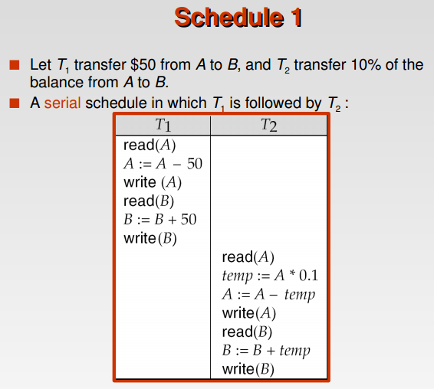

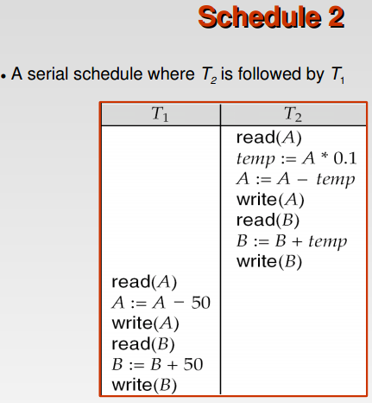
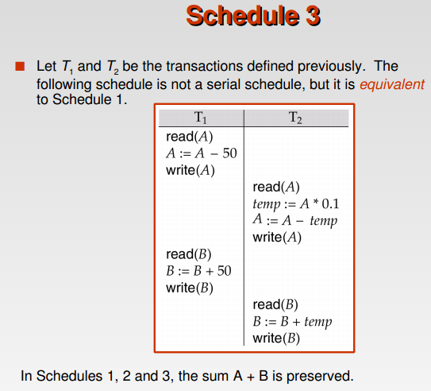
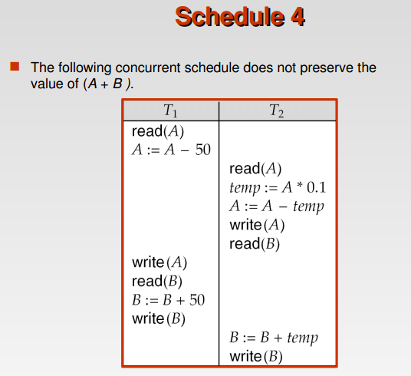

2.5 Transaction Support in SQL
- The definition of an SQL-transaction is similar to our already defined concept of a transaction. That is, it is a logical unit of work and is guaranteed to be atomic.
  - A single SQL statement is always considered to be atomic—either it completes execution without error or it fails and leaves the database unchanged.
- With SQL, there is no explicit Begin_Transaction statement. Transaction initiation is done implicitly when particular SQL statements are encountered.
  - However, every transaction must have an explicit end statement, which is either a COMMIT or a ROLLBACK.
  - Every transaction has certain characteristics attributed to it. These characteristics are specified by a SET TRANSACTION statement in SQL.

  - The characteristics are:
    - The access mode,
    - The diagnostic area size, and
    - The isolation level.
- The access mode can be specified as READ ONLY or READ WRITE. The default is READ WRITE, unless the isolation level of READ UNCOMMITTED is specified, in which case READ ONLY is assumed.
  - A mode of READ WRITE allows update, insert, delete and create commands to be executed.
  - A mode of READ ONLY, as the name implies, is simply for data retrieval.
- The diagnostic area size option, DIAGNOSTIC SIZE n, specifies an integer value n, indicating the number of conditions that can be held simultaneously in the diagnostic area.
  - These conditions supply feedback information (errors or exceptions) to the user on the most recently executed SQL statement.
- The isolation level option is specified using the statement ISOLATION LEVEL <isolation>, where the value for <isolation> can be:
    - READ UNCOMMITTED,
    - READ COMMITTED,
    - REPEATABLE READ, or
    - SERIALIZABLE.
- The default isolation level is SERIALIZABLE, although some systems use as READ COMMITTED their default.
  - The use of the term SERIALIZABLE here is based on not allowing violations that cause dirty read, unrepeatable read, and phantoms.
- If a transaction executes at a lower isolation level than SERIALIZABLE, then one or more of the following three violations may occur:
- Dirty read: A transaction may read the update of a transaction, which has not yet committed. If fails and is aborted, then would have read a value that does not exist and is incorrect.
- Non-repeatable read: A transaction may read a given value from a table. If another transaction later updates that value and reads that value again, will see a different value.
- Phantoms: A transaction may read a set of rows from a table, perhaps based on some condition specified in the SQL WHERE-clause. Now suppose that a transaction inserts a new row that also satisfies the WHERE-clause condition used in, into the table used by. If is repeated, then will see a phantom, a row that previously did not exist.

- Possible Violations Based on Isolation Levels as Defined in SQL:
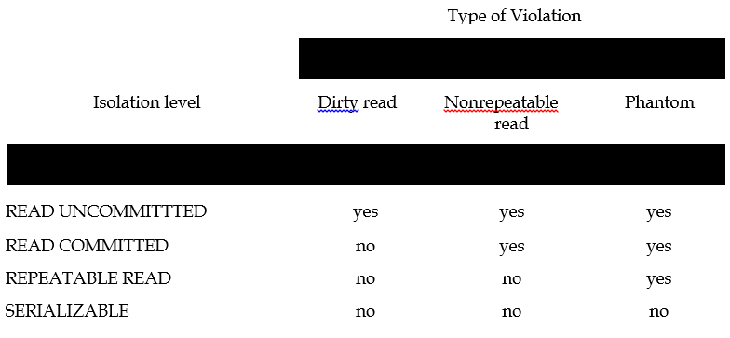
- A sample SQL transaction might look like the following:
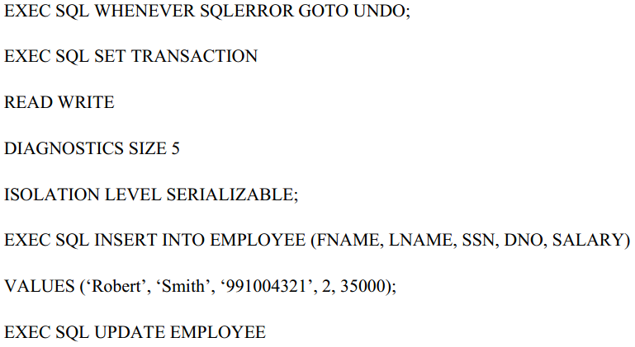
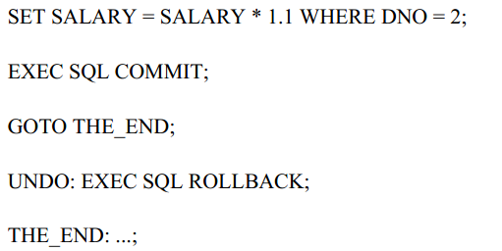
- The above transaction consists of first inserting a new row in the EMPLOYEE table and then updating the salary of all employees who work in department 2.
  - If an error occurs on any of the SQL statements, the entire transaction is rolled back. This implies that any updated salary (by this transaction) would be restored to its previous value and that the newly inserted row would be removed.
- As we have seen, SQL provides a number of transaction-oriented features. The DBA or database programmers can take advantage of these options to try improving transaction performance by relaxing Serializability if that is acceptable for their applications.

CHAPTER – THREE: CONCURRENCY CONTROL TECHNIQUES
Concurrency Control Techniques

3.1 Locking Techniques for Concurrency Control

- Some of the main techniques used to control concurrent execution of transactions are based on the concept of locking data items.
- A lock is a variable associated with a data item that describes the status of the item with respect to possible operations that can be applied to it.
- Generally, there is one lock for each data item in the database. Locks are used as a means of synchronizing the access by concurrent transactions to the database items.
Types of Locks and System Lock Tables:
- Several types of locks are used in concurrency control. To introduce locking concepts gradually:
  - We first discuss binary locks, which are simple but restrictive and so are not used in practice.
  - We then discuss shared/exclusive locks, which provide more general locking capabilities and are used in practical database locking schemes.
Binary Locks
- A binary lock can have two states or values:
  - Locked and unlocked (or 1 and 0, for simplicity).
- A distinct lock is associated with each database item X.
  - If the value of the lock on X is 1, item X cannot be accessed by a database operation that requests the item.
  - If the value of the lock on X is 0, the item can be accessed when requested. We refer to the current value (or state) of the lock associated with item X as LOCK(X).
- Two operations, lock_item and unlock_item, are used with binary locking.
- A transaction requests access to an item X by first issuing a lock_item(X) operation.
  - If LOCK(X) = 1, the transaction is forced to wait.
  - If LOCK(X) = 0, it is set to 1 (the transaction locks the item) and the transaction is allowed to access item X.
- When the transaction is through using the item, it issues an unlock_item(X) operation, which sets LOCK(X) to 0 (unlocks the item) so that X may be accessed by other transactions.
- Notice that the lock_item and unlock_item operations must be implemented as indivisible units (known as critical sections in operating systems); that is, no interleaving should be allowed once a lock or unlock operation is started until the operation terminates or the transaction waits.
- Notice that it is quite simple to implement a binary lock; all that is needed is a binary-valued variable, LOCK, associated with each data item X in the database. In its simplest form, each lock can be a record with three fields:
  - <Data item name, LOCK, locking transaction> plus a queue for transactions that are waiting to access the item.
- The system needs to maintain only these records for the items that are currently locked in a lock table, which could be organized as a hash file.
  - Items not in the lock table are considered to be unlocked.
  - The DBMS has a lock manager subsystem to keep track of and control access to locks.
- If the simple binary locking scheme described here is used, every transaction must obey the following rules:

      - A transaction T must issue the operation lock_item(X) before any read_item(X) or write_item(X) operations are performed in T.
- A transaction T must issue the operation unlock_item(X) after all read_item(X) and write_item(X) operations are completed in T.
- A transaction T will not issue a lock_item(X) operation if it already holds the lock on item X.
- A transaction T will not issue an unlock_item(X) operation unless it already holds the lock on item X.
- These rules can be enforced by the lock manager module of the DBMS.
  - Between the lock_item(X) and unlock_item(X) operations in transaction T, T is said to hold the lock on item X.
- At most one transaction can hold the lock on a particular item.
  - Thus no two transactions can access the same item concurrently.

Shared/Exclusive (or Read/Write) Locks
- The preceding binary locking scheme is too restrictive for database items, because at most one transaction can hold a lock on a given item.
- We should allow several transactions to access the same item X if they all access X for reading purposes only.
  - However, if a transaction is to write an item X, it must have exclusive access to X. For this purpose, a different type of lock called a multiple-mode lock is used.
- In this scheme—called shared/exclusive or read/write locks—there are three locking operations:
  - read_lock(X),
  - write_lock(X), and
  - unlock(X).
- A lock associated with an item X, LOCK(X), now has three possible states:
  - "read-locked,"
  - "write-locked," or
  - "unlocked"
  - A read-locked item is also called share-locked, because other transactions are allowed to read the item, whereas a write-locked item is called exclusive-locked, because a single transaction exclusively holds the lock on the item.
  - One method for implementing the preceding three operations on a read/write lock is to keep track of the number of transactions that hold a shared (read) lock on an item in the lock table.
  - Each record in the lock table will have four fields:
    - <Data item name, LOCK, No_of_reads, locking_transaction(s)>.
  - Again, to save space, the system need maintain lock records only for locked items in the lock table.
  - The value (state) of LOCK is either read-locked or write-locked, suitably coded (if we assume no records are kept in the lock table for unlocked items).
  - If LOCK(X)=write-locked, the value of locking_transaction(s) is a single transaction that holds the exclusive (write) lock on X.
  - If LOCK(X)=read-locked, the value of locking transaction(s) is a list of one or more transactions that hold the shared (read) lock on X.
  - As before, each of the three operations should be considered indivisible; no interleaving should be allowed once one of the operations is started until either the operation terminates by granting the lock or the transaction is placed on a waiting queue for the item.
- When we use the shared/exclusive locking scheme, the system must enforce the following rules:
1. A transaction T must issue the operation read_lock(X) or write_lock(X) before any
read_item(X) operation is performed in T.
2. A transaction T must issue the operation write_lock(X) before any write_item(X)
Operation is performed in T.
- 3. A transaction T must issue the operation unlock(X) after all read_item(X) and
- A binary lock can have two states or values:
  - Locked and unlocked (or 1 and 0, for simplicity).
- A distinct lock is associated with each database item X.

3.2 Concurrency Control Based on Timestamp Ordering

- .

3.3 Multiversion Concurrency Control Techniques

3.4 Validation (Optimistic) Concurrency Control Techniques
:

3.5 Granularity of Data Items and Multiple Granularity Locking
:

3.6 Using Locks for Concurrency Control in Indexes

CHAPTER – FOUR: TRANSACTION PROCESSING
Transaction Processing

4.1 Locking Techniques for Concurrency Control

4.2 Concurrency Control Based on Timestamp Ordering

- .

4.3 Multiversion Concurrency Control Techniques

Validation (Optimistic) Concurrency Control Techniques
- :

4.5 Granularity of Data Items and Multiple Granularity Locking

4.6 Using Locks for Concurrency Control in Indexes

CHAPTER – FIVE: DISTRIBUTED DATABASE SYSTEM
Distributed Database System

Distributed Database Concepts, Data Fragmentation, Replication

.

Allocation Techniques for Distributed Database Design
;

Concurrency Control and Recovery in Distributed Databases

"

Transaction Management in Distributed Databases

Types of Distributed Databases and Distributed DB in Oracle

